

## 

## Topic: Using Icons in Documents to Emphasize Important Information, Talk Tracks, and Recent Updates

The following icons may be added to work instructions and job aids to alert readers to important information within the document:

* The alert icon Icon - Important is used to call attention to important information, warnings, and cautions.
* The HLP alert icon  is used to call attention to important information, warnings, and cautions for the High Level Process.
* The speech bubble icon **Icon - Callout** is used to identify when specific items are to be communicated:
  + - Verbiage/Suggested Verbiage
    - Talk track
    - State
    - Say
    - Advise
    - Instruct
* The yellow flag icon image2s is used to call out document updates.

**Icon use example:**

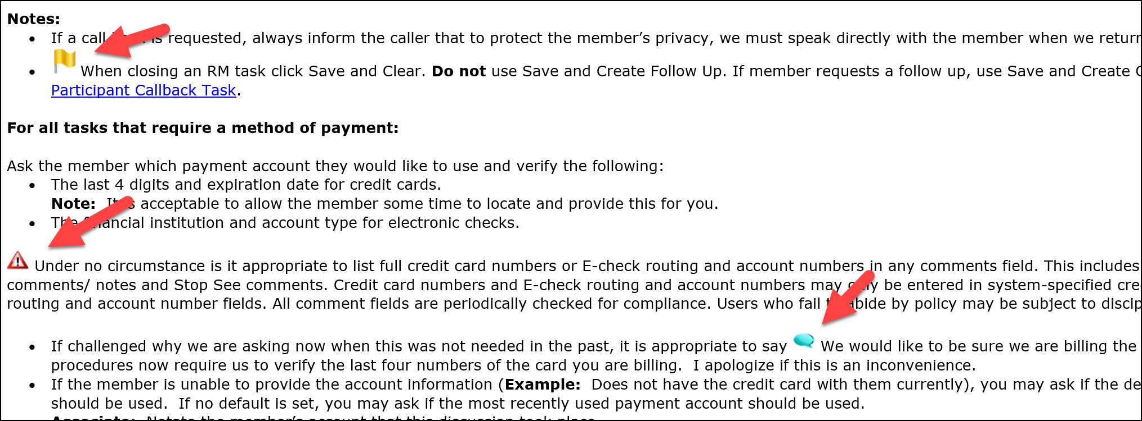

 Your next challenge on the quest to becoming a Certified theSource Wizard is to correctly identify icons appearing in work instructions and job aids in theSource.

Additional resources:

Become a Certified theSource Wizard: Index

Not to Be Reproduced or Disclosed to Others without Prior Written Approval

**ELECTRONIC DATA = OFFICIAL VERSION / PAPER COPY = INFORMATIONAL ONLY**